System Design Tech Devils



Student names: Luuk Vogel/ Mitchell van ‘t Kruys/ Victor Florea/ David Horvath

Student Numbers: 3850560/ 4058151/ 3880346/ 3698009

Group: Tech devils

Date: 01-16-2020

Table of Contents

Description 3

High-Level Design 4

Kitchen System 5

Schematics 5

Description 5

Living Room System 6

Schematics 6

Description 6

Bedroom System 8

Schematics 8

Description 8

Door system 9

Schematics 9

Description 9

Administrator system 11

GUI 11

Description 11

List of reference 12

# Description

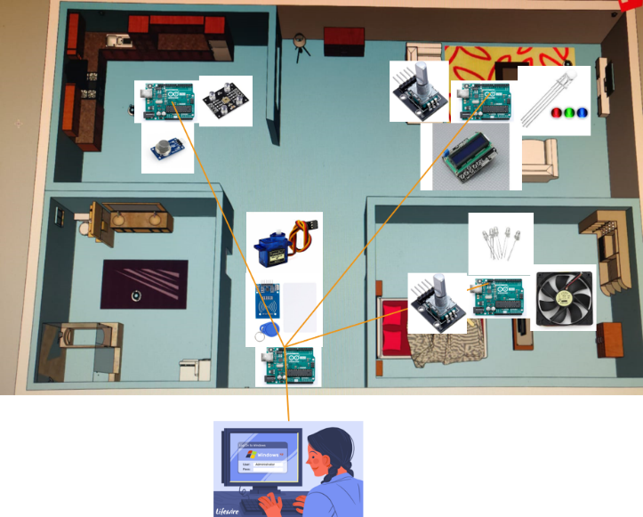

The project system will consist of multiple subsystems. In total there are going to be 4 subsystems that are divided according to the rooms they are going to be installed in (an optional subsystem is the bathroom system). The 4 subsystems are the kitchen system, the bedroom/living room system and the door system (RFID). Each system is going to have different sensors and actuators in order to automate the student’s room. The kitchen system is going to use the MQ-2 gas sensor and the TCS-230 color sensor. The living room/bedroom system is going to use a LCD (16*2) display, a joystick (as a button), RGB lighting, a PIR motion detection sensor, a 12v. Pc fan and a servo (to control curtains). The door system is going to use an RFID sensor and keys. When all these Arduino’s work together as one whole system, the ambient student room will be realized.

The systems in total will communicate with an administrator system through a serial port. The administrator application will be coded with the coding language c#, using the visual studio IDE. the purpose of the administrator application is to manage the system and the occupants. The application can add or remove students from the room. The application can also show information of specified students. The information can contain data such as, which light is being used or what food has been taken out of the fridge. The application will also have the function to show when a smoke alarm has been triggered.

# High-Level Design

# Kitchen System

## Schematics

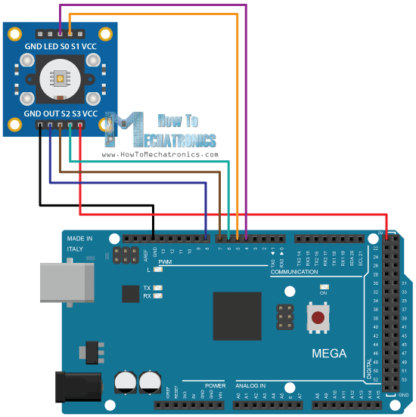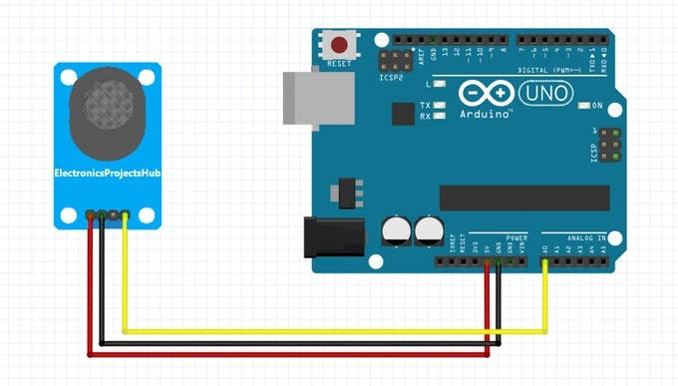

### Description

The kitchen system will consist of 1 Arduino with 2 sensors. The sensors that are going to be used are the MQ-2 gas sensor and the TC230 color sensor. The gas sensor is used for smoke detection and the color sensor is used to detect which color is in front of it. When the gas sensor detects smoke, a buzzer will go off and alert the administrator system (C# application). The color sensor will be acting as a food detection sensor, which detects certain colors. These colors are food items and can be monitored with the administrator system.

#### State diagram

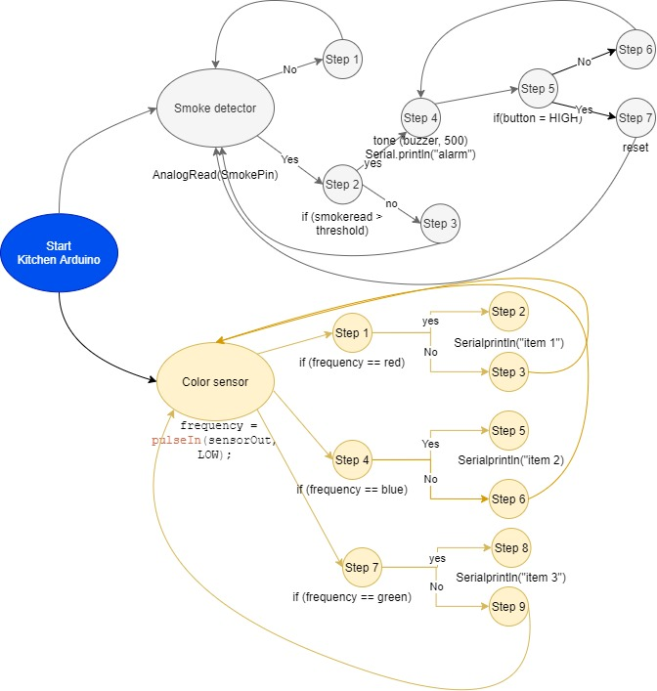

#### Flow chart

# Living Room System

## Schematics

### Description

The Living Room System is going to be based on 1 Arduino with 1 16x2 LCD, a rotary encoder, LEDs and a PIR sensor.  The LCD will act as an interface for the user to control the whole system (fan, lights). A simple menu will be displayed to help the user browse throughout the functions using the rotary encoder. The encoder will allow you to navigate and confirm the actions you want to take. Changing the lights by selecting another preset, changing the fan power or switching the modes of the fan. The mood lighting will consist of a few rgb LEDs which will be controlled by using the menu. The PIR sensor whenever he will detect movement will turn on the LEDs and will turn them off after 5 minutes of not detecting any movement.

#### State diagram

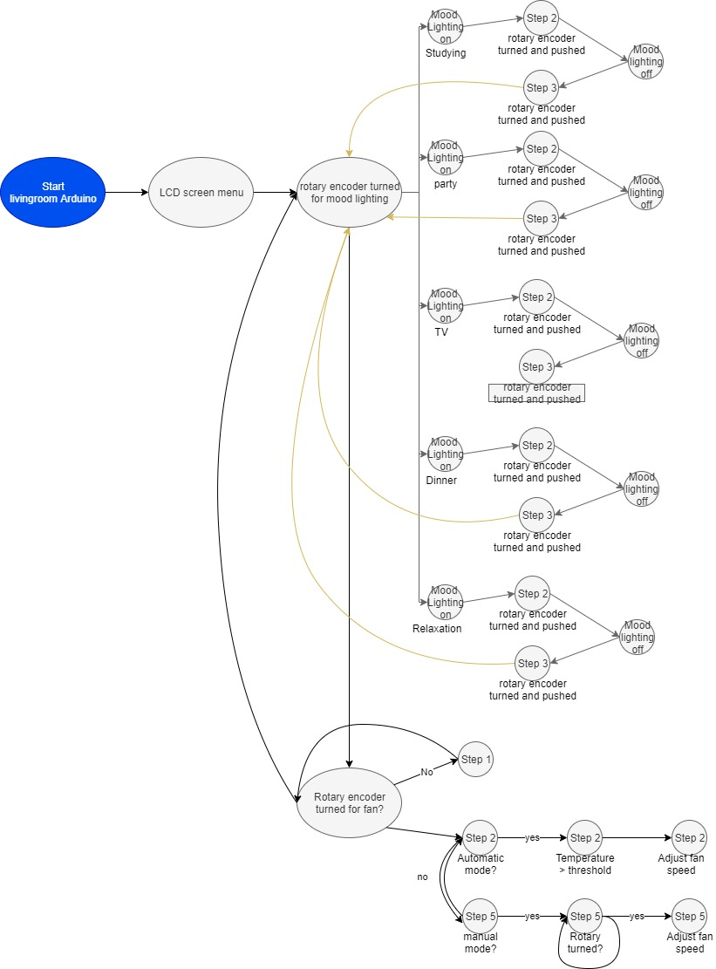

#### Flow chart

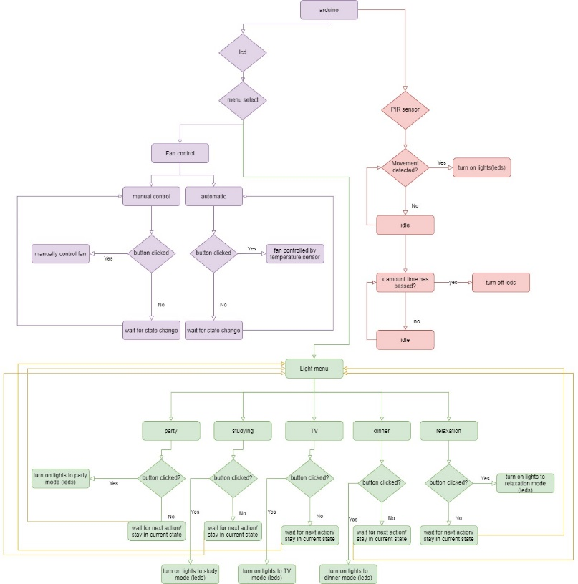

# Bedroom System

## Schematics

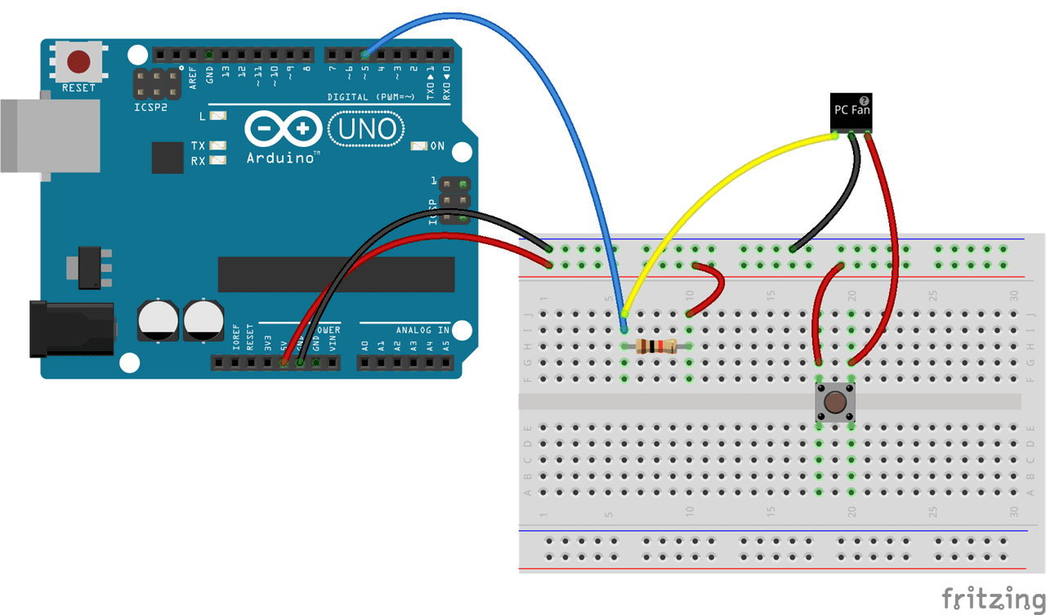

### Description

The bedroom system consists of 1 actuator and a few LED’s. The fan has 2 different modes. The automatic mode and the manual mode. When the system is in automatic mode, the fan speed will adjust according to the temperature. In manual mode the fan speed can be controlled using a rotary encoder. The modes of the fan can also be controlled via the menu screen (living room subsystem) using the rotary encoder.

#### State diagram

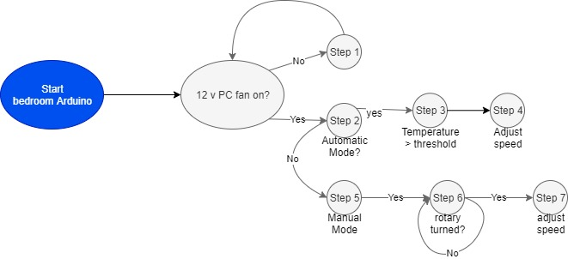

#### Flow chart

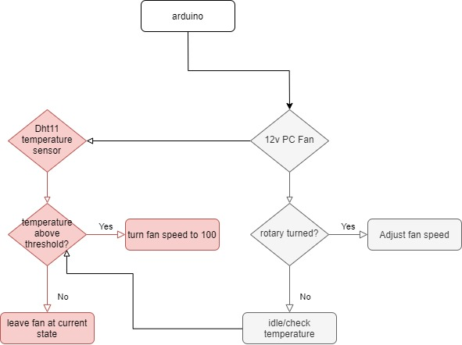

# Door system

## Schematic

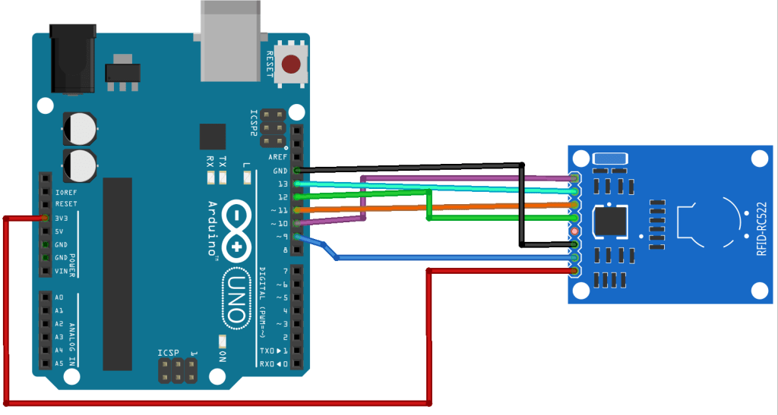

### Description

The digital lock system is based on an RFID-RC522 reader connected to an Arduino Uno board. The reader takes the UID tag from the card/keychain, compares it to the predefined tag in the code to grant/deny access. The door opens by turning a servo to its “unlocked” state and access is granted. After a given amount has passed, the door will automatically close .The door system will send the state of the door (if it has been locked or unlocked) to the GUI application.

#### State diagram

#### Flow chart

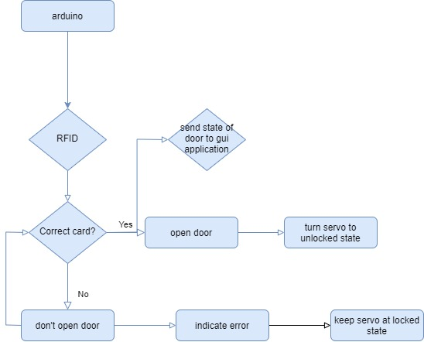

# Administrator system

## GUI

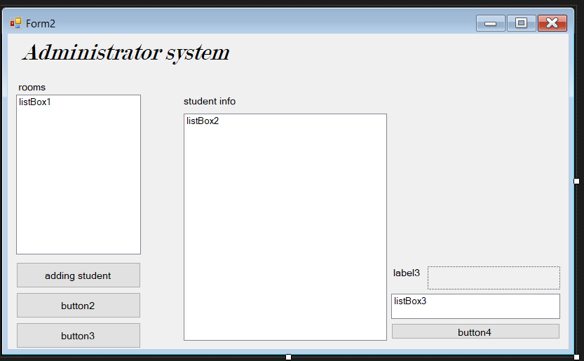

### Description

The administrator system is an application that is going to be used in order to manage the room keys and manage the students. Communication between the application and the systems will happen through serial communication. There are going to be a lot of functions with this system. In the left gui, there will rooms that can be selected in order to rent them. The rooms can be selected and then the administrator can click on a “add student button”. This will allow the administrator to add a student to the room. The administrator also has the option to remove students from a room, if they for example don’t pay rent money. Another button will allow the administrator to show all the details of the room (gui on the right). Here, the administrator, can see all the student’s details, including room details and kitchen(fridge) details, if the student has taken something out of the fridge.

# List of reference

* <https://randomnerdtutorials.com/security-access-using-mfrc522-rfid-reader-with-arduino/>
* <https://learn.adafruit.com/pir-passive-infrared-proximity-motion-sensor/using-a-pir-w-arduino>
* <https://howtomechatronics.com/tutorials/arduino/lcd-tutorial/>
* <https://howtomechatronics.com/tutorials/arduino/arduino-color-sensing-tutorial-tcs230-tcs3200-color-sensor/>
* <https://create.arduino.cc/projecthub/Junezriyaz/how-to-connect-mq2-gas-sensor-to-arduino-f6a456>